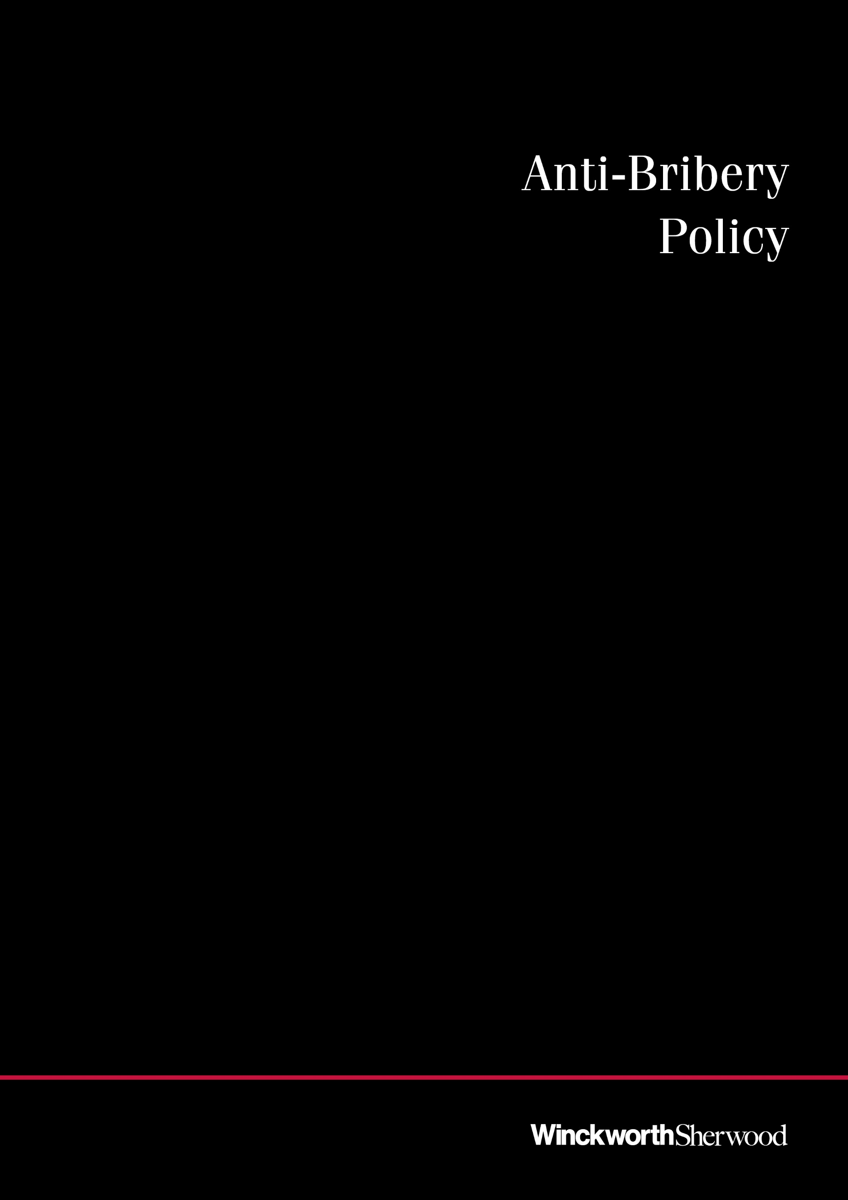

January 2021

CONTENTS

INTRODUCTION 2
ABOUT BRIBERY 3
PREVENTING BRIBERY 4
GIVING GIFTS 7
RECEIVING GIFTS 8
HOSPITALITY 8
‘RED FLAGS’ 10

INTRODUCTION
About this policy
Winckworth Sherwood’s policy is to be honest and ethical in everything we do. We act professionally, fairly and with integrity in all our business dealings and relationships, whether with clients, suppliers, our staff or others.
We condemn bribery in all its forms and will not tolerate it within our business or in those that we do business with. The firm will always stand by you in acting ethically.
This policy sets out how we can take steps to avoid becoming involved in bribery and corruption and what to do if you are confronted with it. It should be read by all individuals working with or for the firm, including partners, consultants, employees, contractors, vacation scheme students and agency staff.
This policy is designed to be helpful to each of us as individuals as well as to the firm itself. If an individual is convicted of a bribery offence, Winckworth Sherwood might get a significant fine, find itself barred from future tendering exercises, and suffer lasting reputational damage. The individual concerned could face up to ten years in prison and may suffer lasting damage to their career.
The potential harm caused by bribery, both to Winckworth Sherwood and to each of us, is long term and severe. It is therefore vitally important that this policy and its values are embraced in our day-to-day work.
If you have any doubts about any aspect of this policy, or about bribery in general, please speak to me in confidence. With your feedback we can further develop this policy so that it is a useful and relevant tool for us all.
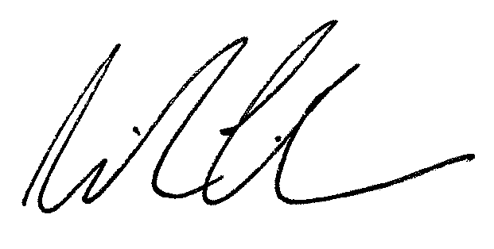
Richard Tinham
Anti-bribery compliance officer

ABOUT BRIBERY

The Bribery Act 2010 restated and modernised the law on bribery. It introduced severe criminal penalties and, for the first time, makes a commercial organisation criminally liable for bribery committed by those performing services for it.
Under the Act, both the making and receiving of bribes are criminal offences.
A person makes a bribe if he or she offers or makes a payment to someone (or favours them in some other way) and in doing so:
- hopes that a person will somehow misuse their position; or
- is rewarding the fact that a person has misused their position.
A person receives a bribe if he or she misuses their position in connection with payments (or other favours) for themselves or others.
These offences are very wide. In particular:
- Bribes can be in cash, but may also be (and commonly are) another sort of advantage. They can include physical gifts, hospitality such as travel and entertainment, promises of future business, or even donations to a chosen charity.
- Bribes can be of any size. They can include small payments to ensure that a matter is dealt with quickly and simply (‘facilitation payments’) or unofficial inducements from those connected with suppliers (‘kickbacks’).
- The person receiving the bribe need not be the same person as the person who misuses their position – a bribe may be paid to their spouse or colleague, for example.
- Misusing one’s position is not at all restricted to public officials – a person might just as easily misuse their position as a director or employee of a company, or as a trustee of a trust.
Making and receiving bribes are serious offences which carry possible sentences of imprisonment for ten years and unlimited fines. However, importantly, when a person providing services for an organisation commits bribery hoping to secure an advantage for that organisation, the organisation also commits a crime. It is therefore likely that a bribe made by a partner, consultant, employee or contractor of Winckworth Sherwood would also result in the firm committing an offence, which would have disastrous consequences for our business.

PREVENTING BRIBERY

There are simple rules that we must all follow in order to reduce the risk of becoming involved with bribery.

Prohibited activities
It is not acceptable to:
- give (or promise or offer to give) any payment or other favour, including pro-bono or reduced rate legal services, in the expectation or hope that a person will misuse their position to provide the firm with an advantage;
- give (or promise or offer to give) any payment or other favour to any person in order to facilitate or expedite a routine procedure;
- accept payment or another favour from a third party that you know or suspect is offered with the expectation that it will help them obtain a business advantage;
- give or accept gifts or hospitality except as permitted by this policy;
- threaten or retaliate against another individual who has refused to commit a bribery offence or who has raised concerns under this policy; or
- engage in any other activity that might lead to a breach of this policy.
The following chapters of this policy contain guides on the giving and receiving of gifts and hospitality in order to help clarify when those matters are, and are not, acceptable.

Donations
Winckworth Sherwood does not make contributions to political parties.
The firm may make charitable donations if it is lawful and ethical for it to do so. Charitable donations will normally be made through the firm’s corporate social responsibility programme or as part of an organised corporate sponsorship or donation scheme operated by a charity that is registered (or exempt from registration) under UK law. The firm may also make ad hoc donations to other charities, but it shall do so only of its own initiative and not at the request of a third party. All charitable donations must be bona fide donations in support of the charity’s objects and not made with any expectation that the firm will receive an advantage.

Notification
It is everyone’s responsibility to read, understand and comply with this policy and to help to detect, prevent and report acts or attempts of bribery and potential risks of bribery. Remember that this includes acts or attempts carried out by third parties carrying out services for us, such as our contractors.
You must notify the firm’s compliance manager as soon as possible if you believe or suspect that a conflict with this policy has occurred, or if you believe that there is a risk of such a conflict in the future.
The compliance manager must also be informed as soon as possible if you become a victim of bribery – such as if you are offered a bribe, are asked to make one, suspect this may happen in the future or are a victim of the consequences of bribery by others.
All concerns will be handled sensitively and the firm will support anyone who raises genuine concerns in good faith under this policy, even if they turn out to be mistaken. No person shall suffer detrimental treatment for refusing to take part in bribery or for raising concerns in good faith. If you believe that you have suffered detrimental treatment for these reasons, you should inform the compliance manager immediately or raise the issue formally following the firm’s grievance procedure.
Any employee who breaches this policy will face disciplinary action, which could result in dismissal for gross misconduct. The firm is likely to terminate its contractual relationship with consultants and contractors if they breach this policy. The firm is also likely to report the matter to the police or Serious Fraud Office.

Record-keeping
The firm must keep financial records and have internal controls in place which will evidence payments to third parties and the business reasons for them.
You must therefore ensure that all expenses claims relating to hospitality, gifts or expenses incurred in relation to third parties are paid through the firm’s normal systems, and that records are maintained in accordance with the firm’s file management policies.
All accounts, invoices, memoranda and other documents and records relating to dealings with third parties (such as clients, suppliers and business contracts) must be prepared and maintained with strict accuracy and completeness. On no account must accounts be kept ‘off-book’ to facilitate or conceal any payments.
When giving or receiving gifts and hospitality, and as a required step in reclaiming expenditure occurred, a yellow ‘GIFTS AND HOSPITALITY’ form (or suitable electronic equivalent) must be completed and authorised by a partner. Copies of these forms are available from Admin and guidance notes are printed on the back of each form.

Engaging contractors
Our zero-tolerance approach to bribery must be communicated to all suppliers, contractors and other businesses with whom we contract at the outset of our business relationship and as appropriate thereafter.
It will often be appropriate to include terms allowing the firm to terminate contractual relationships and seek damages in the event of bribery being committed by our contractual partners, whether in relation to our contract or not. The firm’s compliance manager can advise as necessary.

Who is responsible for this policy?
The firm’s Partnership Committee has overall responsibility for ensuring that this policy complies with our legal and ethical obligations, and that it is complied with by all those affected by it.
The firm’s compliance manager has primary and day-to-day responsibility for implementing this policy, and for monitoring its use and effectiveness and dealing with any queries on its interpretation. Management at all levels are responsible for ensuring that those reporting to them are made aware of and understand this policy and are given adequate and regular training on it.
We are all responsible for the success of this policy and for using it to identify and notify any suspected danger or wrongdoing.

Monitoring and review
The firm’s compliance manager will monitor the effectiveness and review the implementation of this policy and shall regularly consider its suitability, adequacy and effectiveness. Any improvements identified will be made as soon as possible. Internal control systems and procedures will be subject to regular audits to provide assurance that they are effective in countering bribery.
Everyone is invited to comment on this policy and to suggest ways in which it might be improved. Comments, suggestions and queries should be addressed to the compliance manager.

Contracts of employment
This policy does not form part of any employee’s contract of employment and may be amended at any time.

GIVING GIFTS

Our day-to-day business does not require us to routinely provide gifts and, as doing so gives rise to potential allegations of bribery, care should always be taken.

High Risk
Not permitted
- Gifts of cash (or cash equivalent, such as gift vouchers) other than charitable donations made in accordance with this policy
- Gifts given at the suggestion of the recipient or in lieu of normal payment.
- Gifts made with the intention of obtaining a business advantage.
- Gifts in exchange for other gifts or favours.
- Gifts which the recipient could not disclose to his or her management without embarrassment or gifts to those whom we believe to be subject to restrictions on the acceptance of gifts.

! | Potential risk  Seek advice from compliance manager before giving
- Gifts (other than simple Christmas cards) to those holding governmental or judicial office.
- Gifts with a value exceeding £50.

Generally OK
Seek advice from compliance manager if unsure
- Customary small gifts and cards at Christmas.
- Gifts with an appropriate value (maximum £50) given in the name of the firm to thank a person for performing a legitimate activity or to celebrate an important event. Taking into account the reason for giving it, the gift must be of an appropriate type and given at an appropriate time. For example:
  - a gift of flowers or a bottle of wine made to a guest speaker at a conference organised by the firm; or
  - a gift to a person retiring from the firm.
- Charitable donations made in accordance with this policy.

RECEIVING GIFTS

In addition to this policy, we are also under a professional duty not to accept gifts of significant value from clients unless they receive independent legal advice.
High Risk
Reject gift and notify compliance manager
- Gifts of cash (or cash equivalent, such as gift vouchers) other than gifts made as part of our corporate social responsibilitiy activities which are to be remitted to a registered or exempt charity.
- Gifts made with the intention of obtaining a business advantage.
- Gifts made secretly.
- Gifts which cause embarrassment or which are provided without a clear purpose.

! | Potential risk  Seek advice from compliance manager before accepting
- Gifts from suppliers.
- Gifts with a value exceeding £100.

Generally OK
Seek advice from compliance manager if unsure
- Customary small gifts and cards at Christmas.
- Gifts with an appropriate value (maximum £100) given by clients to express their appreciation on the conclusion of, or at a significant milestone in, a matter in which we act.
- Gifts with an appropriate value (maximum £100) given to express thanks for the performance by us of a legitimate activity, such as speaking at a conference, and which have (if of a value of £20 or more) been recorded
- Gifts for the explicit purpose of supporting our corporate social responsibility activities and which are to be remitted to a registered or exempt charity.

HOSPITALITY

The Bribery Act 2010 does not prevent normal and appropriate hospitality. Nevertheless, hospitality may become a mechanism for bribery and care should be taken.
High Risk
Not permitted
- Invitations to events at which representatives of the firm will not be present.
- Hospitality which the recipient could not disclose to his or her management without embarrassment or which conflicts with restrictions applicable to the recipient on the acceptance of hospitality.

! | Potential risk  Seek advice from compliance manager before offering or accepting  (unless approval sought and received under the firm’s expenses policy)
- Restaurant / bar entertainment for which the cost per participant exceeds £100.
- Sporting or cultural events for which the cost per participant exceeds £200.
- Inappropriately frequent hospitality or hospitality with an unclear purpose.
- Foreign travel or hotel accommodation, except purely for the purpose of travelling to a person’s residence or normal place of business.

Generally OK
Seek advice from compliance manager if unsure
- Office meetings, conferences and marketing events together with normal catering provision.
- Breakfasts, lunches, dinner or drinks meetings or invitations to sporting or cultural events, for the purpose of:
  - explaining the business services provided by the participants;
  - getting to know a person or business to aide our future working relationship;
  - introducing colleagues who are likely to work with that person or business;
  - discussing a current matter; or
  - keeping in touch with an existing client or contact;
at a location which is appropriate to the purpose of the meeting and its participants and which, considering all the circumstances, is not unduly lavish.
- Appropriate events celebrating the completion of, or the reaching of an important milestone in, a matter.

‘RED FLAGS’

The following scenarios may raise concerns of bribery and should be reported promptly to the firm’s compliance manager if encountered.
- You become aware that a third party engages in, or has been accused of engaging in, improper business practices;
- You learn that a third party has a reputation for paying bribes, or requiring that bribes are paid to them, or has a reputation for having a ‘special relationship’ with foreign government officials;
- A third party insists on receiving a commission or fee payment before committing to sign up to a contract with us, or carrying out a government function or process for us;
- A third party requests payment in cash and/or refuses to sign a formal commission or fee agreement, or to provide an invoice or receipt for a payment made;
- A third party requests that payment is made to a country or geographic location different from where the third party resides or conducts business;
- A third party requests an unexpected additional fee or commission to "facilitate" a service;
- A third party demands lavish entertainment or gifts before commencing or continuing contractual negotiations or provision of services;
- A third party requests that a payment is made to "overlook" potential legal violations;
- A third party requests that you provide employment or some other advantage to a friend or relative;
- You receive an invoice from a third party that appears to be non-standard or customised;
- A third party insists on the use of side letters or refuses to put terms agreed in writing;
- You notice that we have been invoiced for a commission or fee payment that appears large given the service stated to have been provided;
- A third party requests or requires the use of an agent, intermediary, consultant, distributor or supplier that is not typically used by or known to us;
- You are offered an unusually generous gift or offered lavish hospitality by a third party.

For further information please contact:
Richard Tinham
Anti-bribery Compliance Manager
T: 020 7593 5165
E: rtinham@wslaw.co.uk

